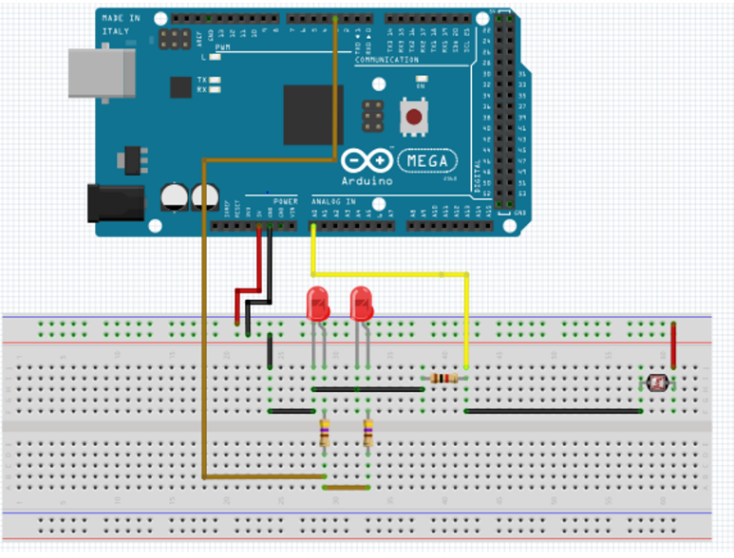

<https://www.allaboutcircuits.com/projects/an-arduino-controlled-light-sensor/>

References:

<http://forum.arduino.cc/index.php?topic=286509.0>

<https://www.instructables.com/id/Arduino-LDR-With-LED/>

<https://www.allaboutcircuits.com/projects/an-arduino-controlled-light-sensor/>

<https://www.instructables.com/id/Arduino-Mega-2560-based-LDR-Light-Intensity-Contro/>

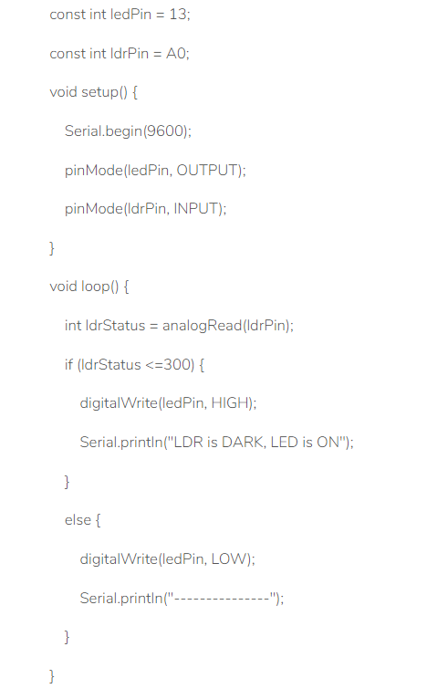

<https://www.instructables.com/id/Arduino-LDR-With-LED/>

